Mistborn: The Final Empire

# Version 1.0

Table of Contents

Executive Summary 3

Character Design: Vin 4

**Physical Description:** 4

**Background:** 4

**Likes:** 5

**Dislikes:** 5

**Strengths:** 5

**Weaknesses:** 5

**Mannerisms and Animations:** 5

World Design 6

User Interface Design 8

Flowboards 9

**Main Menu** 9

**The Options Menu, Accessible from the Main Menu** 10

**New Game Menu** 11

**Normal Gameplay** 12

**Inventory Menu** 13

**Map Menu** 14

**Skills Menu** 15

**Quests Menu** 16

**Codex Menu** 17

**In-Game Options Menu** 18

Story and Level Progression 19

On-Screen Text and Audio Dialog Script 19

Game Script 19

**Movement:** 19

**Allomantic Powers:** 19

**Combat:** 20

**Levelling Up:** 20

**Upgrades:** 20

# Executive Summary

Mistborn is an adaptation of the book *Mistborn: The Last Empire*, written by Brandon Sanderson. The players play as Vin, a young woman saved by charismatic Kelsier, who discovered that she is one of the rare mistborn, like himself. Kelsier and his crew of honorable thieves are going to attempt the heist of the millenia. Not only are they going to loot the god-like immortal Lord Ruler’s Inner Sanctum, but they are determined to kill him and end his 1,000-year reign, while inciting a revolution and toppling the oppressive Nobles, the ruling class and favored race of the Lord Ruler.

Gameplay and the story revolve around the magic of Allomancy. Allomancy is the ability to “burn” ingested metals to perform various feats, depending on which metal you ingest and metabolize. There are ten known metals that grant ten different allomantic powers. They each come in pairs of 2, complementing each other. The first two metals are iron and steel. By metabolizing (hereafter referred to as burning) iron, an iron misting or mistborn can pull any metal directly toward himself. Burning steel is the exact inverse of that, allowing the user to push anything metallic. The user’s weight is taken into account, so if, for example, the allomancer pushes against something heavier than himself, rather than pushing the object away from him, he would push himself away from the object. The next pair is tin and pewter. Tin enhances every sense and is the slowest burning metal. Pewter, on the other hand increases physical abilities (speed, strength, pain tolerance, speed of healing) but burns the fastest. The pair following that is brass and zinc. Brass dampens the emotions of the target, while zinc is used to enhance a targets current emotion. It should be noted that these powers influence the severity of an emotion, not the actual emotion being felt. The final common pair is bronze and copper. Burning bronze allows the user to detect pulses given off by anyone using any allomantic power. With practice, distinct rhythms can be attributed to each power type. Alternatively, by burning copper, the user creates a sizable bubble that hides the allomantic pulses of anybody inside the bubble. In other words, anybody inside the bubble can use allomancy without worrying if someone burning bronze outside the bubble will be able to detect them. Metal number nine is gold, which will be shown in an interactive cutscene, but not used in regular gameplay. Burning gold allows the user to see a past version of themselves. The final known metal is Atium. Atium allows the allomancer to see several seconds into the future, rendering them practically invincible as they are able to anticipate every action taken and adjust for it. The only way to contend with someone burning Atium is the burn Atium as well. Then both users will see a jumble of possible futures, rendering both allomancers’ Atium burning pointless. Because of the strategic value of Atium for the mistborn, Atium has become the most precious metal beads of the metal are used in high end trades. During the game’s time period, it is believed that only the mistborn are able to burn Atium.

Allomancy is a hereditary trait that the Lord Ruler gifted to the first Nobles at the beginning of his reign 1,000 years ago. The mistborn are those who are able to use all 10 of the known allomantic abilities. Mistborns have become exceedingly rare, and instead most allomancers are only able to burn one metal, use one power. They are called mistings. To keep this power away from the oppressed Skaa, the Lord Ruler requires that the Nobles do not have any children with the Skaa. Any Skaa found using any allomantic abilities are immediately put to death. This makes Kelsier and Vin, the only Skaa mistborns alive, very wanted and very dangerous…

Gameplay will revolve around using these powers and stealth mechanics in tandem to complete mission objectives. Objectives can include assassinations, battles, recruiting rebellious skaa, thievery, inciting a revolution, etc. These powers offer amazing potential for open-ended methods for completing objectives. Pure stealth, creating environmental chaos and pure melee are all viable options to tackling situations, as well as everything in between.

# Character Design: Vin

Vin is the main protagonist and one of two playable characters. Vin will be the player’s avatar for the majority of the game.

**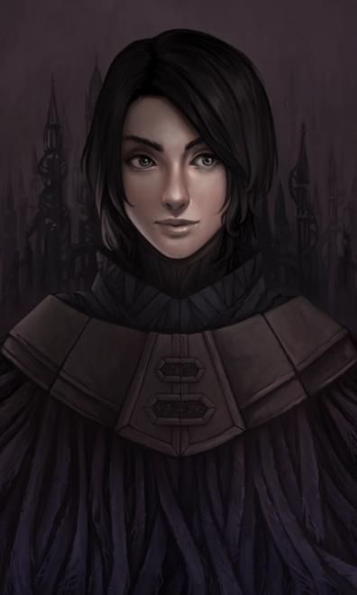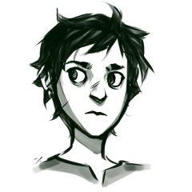****Physical Description:** Vin is not a physically imposing character. She is about 16, short (about 5’ 2’’), scrawny (about 100 lbs) and relatively flat-chested. Vin has very little strength when not burning pewter to allomantically enhance her strength, so does not look very muscular. She has a pale skin tone and raven black hair cut short. She has a single simple earring that she wears in one ear. This earring is a huge plot twist by the third entry in the series, so it is important that it is visible, though not too obviously pointed out.

Vin the Street Urchin

Courtesy of Luaru

Portrait of Vin

Courtesy of Reiyeka

Vin despises wearing dresses, preferring a mist-cloak and a pair of trousers whenever possible and never wears shoes. She dresses in blacks or dark browns, because those colors blend into the night best. Her mist-cloak is made up of a cloak with countless long, flowing tassels that flutters behind her, curling the mist it passes through. These cloaks have been traditionally been worn by the Mistborn, and she takes right to them. Strapped to her belt she always carries an obsidian knife (because it can’t be allomantically pulled), extra vials of metal shavings, and a bag of copper clips (the smallest denotation of currency) to use as impromptu jump-off points.

During certain sections of the game, Vin is forced to impersonate a noblewoman. During these times, she wears extremely fancy ballgowns and necklaces, though she passes up fancy earrings in favor of her own. Though the clothes look appealing, Vin looks a touch awkward in them.

**Background:** In the world of Mistborn, there are 2 castes, the Nobles and the Skaa. The Nobles are the upper ruling class, and the skaa are considered as little more than slaves. Vin is the daughter of a high ranking Noble and a Skaa prostitute. As a toddler, Vin’s insane mother killed her baby sister with an earring then gave it to Vin. At this point, Vin’s older half-brother Reen took Vin away and raised her himself. In trying to teach Vin in what he thought she needed to survive, Reen would beat Vin for doing anything that drew attention to herself and forced her to learn to live on the streets and as part of the Skaa underground. He instilled in her the belief that you can’t trust anyone because they will only hurt you, then he left her.

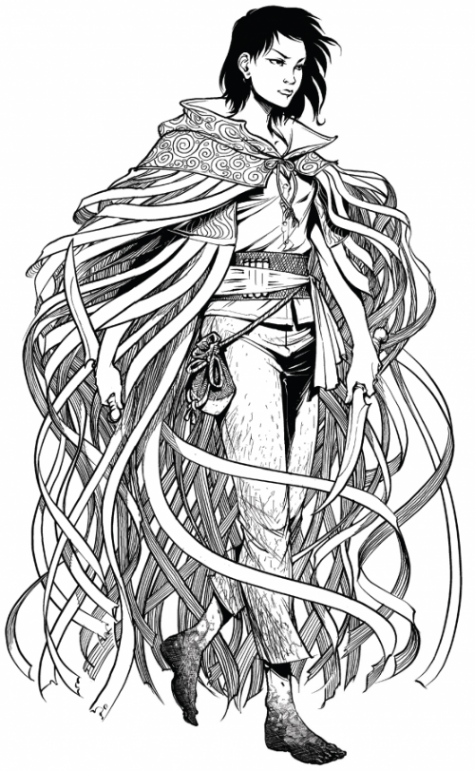 Due to this upbringing Vin finds it extremely difficult to trust. She is extremely cautious and suspicious of everyone. She does everything she can to remain unnoticed and seemingly unimportant. When she gets anxious or scared, she tries to hide, pulling her knees her chest and making herself as small as possible. She will do whatever she can to seem submissive, but there is a fire and a survivors passion within. She would rather be alone than with company, because whoever it is will just leave her anyway.

Vin the Mistborn

Courtesy of Ben McSweeney

**Likes:** Solitude, the freedom and anonymity being out in the mist provides, learning.

**Dislikes:** Social gatherings, being around people

**Strengths:** A survivor, lithe and agile, quick-thinking, very intelligent, fiercely loyal to, and protective of, those whom she loves and have earned her trust

**Weaknesses:** Hardened, finds it hard to empathize, pushes people away, highly untrusting, struggles to handle emotions, especially positive emotions. She is afraid of getting hurt by those emotions and that clouds her judgment.

**Mannerisms and Animations:** At the beginning of the game, Vin does everything she can to be small and unnoticed. Largely blank expressions, never looking up, shoulders slumped and head down. At rest, she either sit with her legs pulled up to her chest or stand in a corner with her shoulders rolled forward, head bowed, and hands clasped in front of her. She cowers at everything trying to seem harmless, but she knows her limits and will run from a situation if she has to. When walking, she moves very lithe and nimbly.

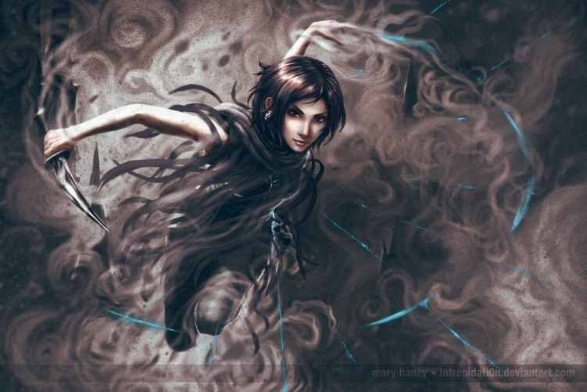As the game continues on and Vin gets to know Kelsier and his crew, she begins to open up. As she learns of, and how to use, her abilities, she begins to walk straight, look up, and show expression. Her inner strength shows, and even though she is diminutive, her posture screams strength.

Vin in her Mistcloak

Courtesy of intrepidati0n

When in motion, she still moves nimbly, but brings to mind a cat on the prowl. If her hands are empty, they are about waist height, in case she needs to grab anything from her belt. When in combat, she has a fierce determined expression. She won’t go out of her way to kill, but she won’t hesitate either.

When Vin is stopped, she tends to perch. She’ll perch on a chair, a counter, a cabinet. The height gives her a better vantage of what’s around her, and the crouching means she’s ready to spring into action should anything happen. She always stands with a back to a wall. She doesn’t want any enemies to get behind her.

Some at-rest animations could include cleaning her dagger, checking her metal vials, allomantically pushing and pulling a copper clip, pulling her mist-cloak up around her shoulders, and fingering her earring.

# World Design

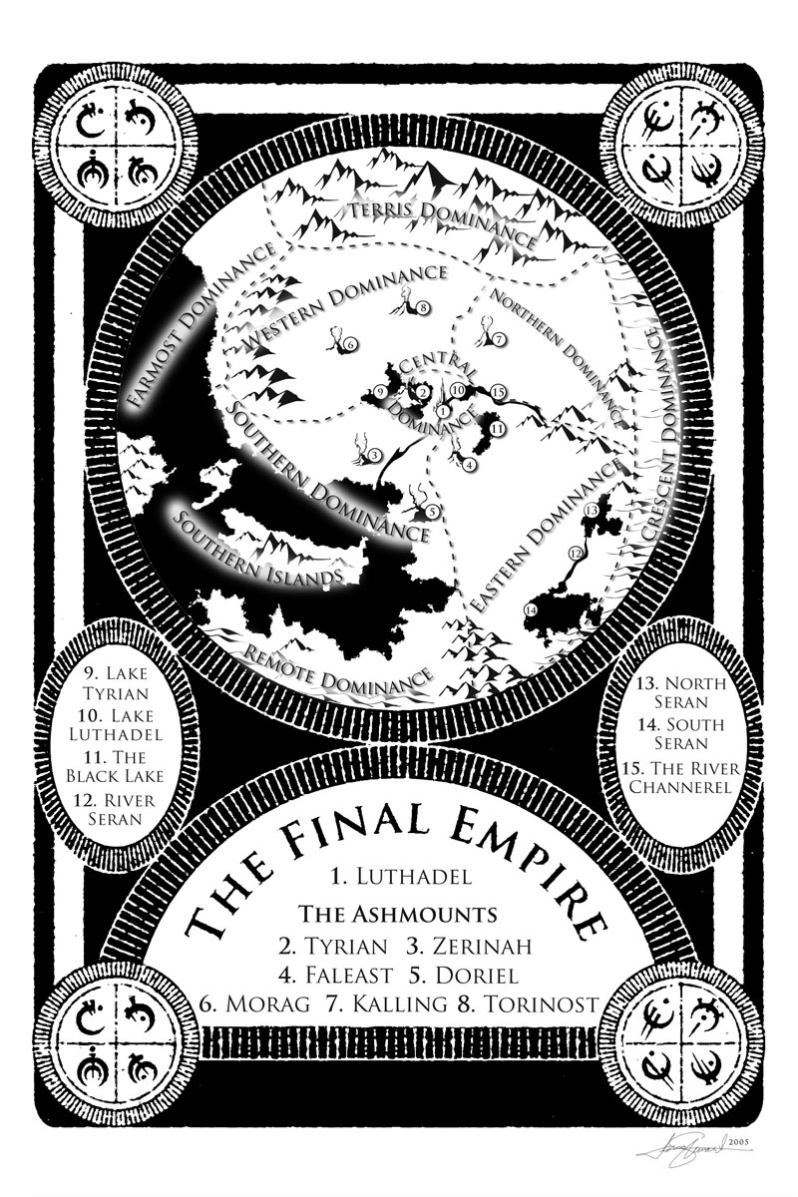 Mistborn takes place on the planet Scadriel. 1000 years ago, Scadriel was like earth. However, for reasons that will be hinted at in this entry, and slowly revealed in the second and third entries, the landscape and geography of the entire planet changed. No longer is there a blue sky with numerous plants and animals. Instead 5 volcanoes constantly belch ash and noxious gases into the sky, creating an atmospheric umbrella that blocks enough of the scorching sun’s light to make the planets surface cool enough to be livable. Outside this umbrella the Ashmounts produce, located at the northern pole of the planet, is a vast, unlivable desert called the Burnlands.

Map of the Final Empire, as found in the book Mistborn

The livable area of land is ruled by the Lord Ruler and is called the Last Empire. The sky is a constant grey with a never-ending ashfall. This means that everything is stained with suit, except the houses of the richest Nobles, who make their Skaa servants constantly clean and white wash their buildings. Even though the soot is constantly being swept into the rivers, there are always piles of soot in the corners and hard to sweep areas. The ever-present soot makes the world a very monochromatic landscape, with everything in blacks and browns. The upper-class and the privileged are always easy to pick out because of the simple fact that they can afford to take care of things that have color.

As far as life goes on the planet, not much survived the change. Plants are all a shade of brown, with no greenery to be seen anywhere. The only common animals to be found in the Final Empire are hardy horses and dogs. In the empty plains between cities, mistwraiths scavange for food. Mistwraiths 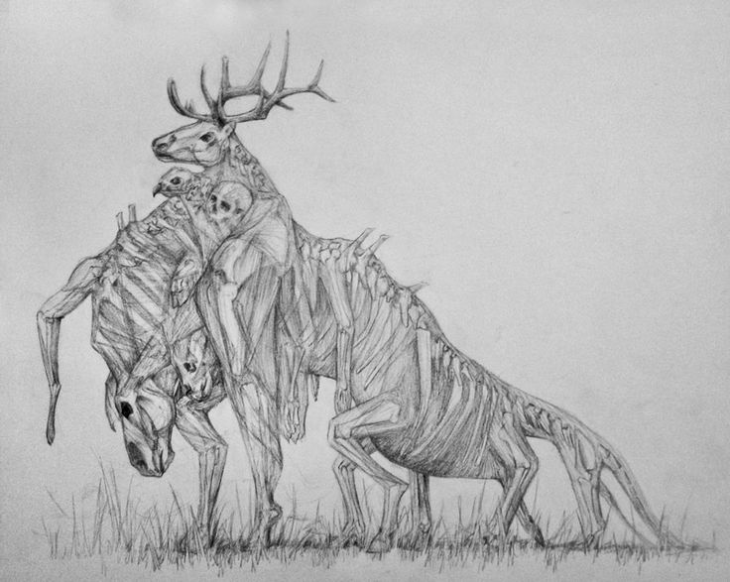are transparent piles of muscle that digest food by incorporating it into their mass. They will assemble the bones they ingest into makeshift skeletons. While terrifying in appearance, they are practically harmless, having no aggressive tendencies and only scavenging corpses.

A Mistwraith

Courtesy of MeltingThoughts

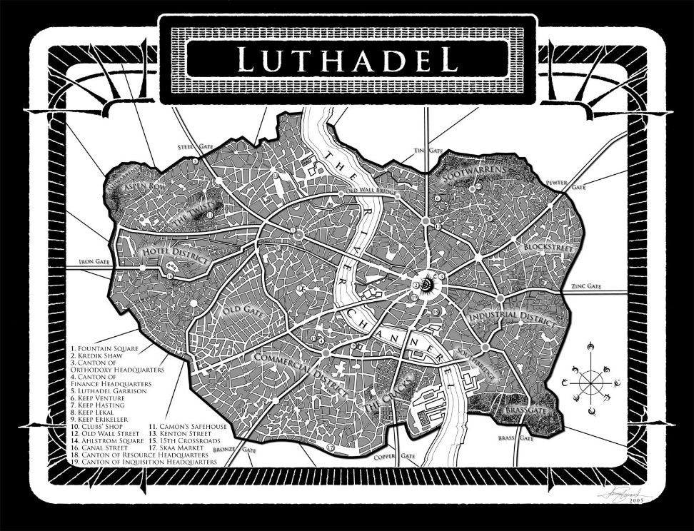The majority of the game takes place in Luthadel. Luthadel is the capitol city of the Final Empire and home to the Lord Ruler’s palace, Kredik Shaw, the Hill of a Thousand Spires. It is absolutely immense with spires of countless different lengths and thicknesses. Kredik Shaw lies just to the east of the River Channerel, which cuts the Luthadel right down the middle. From Kredik Shaw radiates 8 roads leading to the eight gates that allow entry into the city. Each of the eight gates is named after one of the 8 common metals that grant allomantic abilities, Iron, Steel, Tin, Pewter, Brass, Zinc, Copper, and Bronze. At different places within the city, the four most powerful noble families control grand Keeps, patterned after Kredik Shaw. In these keeps, on a weekly rotation, the Ruling Families, as they are called, host balls. The balls are extravagant affairs, full of posturing and political intrigue. All important political maneuvers and deals are struck at these balls, and there is nothing that compares to the sheer elegance that is exhibited. Stained glass windows have limelights showing through them and no expense is spared as week after week, the ruling families try to out-do the other until they run out of funds and a new house steps in.

Map of Luthadel, as found in the book Mistborn

The inner sections of the city house nobles, businesses and merchants, including the occasional middle class Skaa craftsman. Skaa janitors are constantly sweeping the ash off the streets and into barrows to be dumped into the River Channeral, and carriages are not uncommon. As the distance from Kredik Shaw and each respective keep increases, the buildings become more rundown, and the atmosphere seedier. Houses and shops give way to tenements and brothel. The streets change from well swept and clear to ash hastily pushed around and piled up along walls and corners. Beggars and shifty characters lurk in every corner, and every child could very well be a member of a thieving crew. Nobles abusing and mistreating the Skaa and Skaa prostitutes getting put to death by their noble clients is not uncommon and there is an atmosphere of oppression and hopelessness pervading the entire area.

The base of operations for Kelsier’s crew is along the edge of the commercial district. Their front is the shop of Clubs, a successful Skaa woodworker. They work out of the upper floor. Kelsier has his blackboard full of notes and there are always several members of the crew present, discussing tactics or just enjoying each other’s company. On the bottom floor Clubs and his apprentices have a workshop to produce their woodwork and a storefront in order to keep up their front.

# User Interface Design

Button mapping will be based on the DualShock 4 controller by playstation, but should be equally effective with an Xbox One controller and can be mapped out on a keyboard.

**Main Menu:** The main menu opens with Vin on the left of the screen holding onto a spire as she gazes across Luthadel, with Kredik Shaw in the background. Her cape will be fluttering and intense orchestral music will be playing. At the top center of the screen is “Mistborn” a little less than halfway down the screen, also centered, begin the menu options: “Continue”, “Load Game”, “New Game”, “New Game+”, “Options”. If no saved games are found, “Continue” and “Load Game” will be greyed out and unable to be selected. “New Game+” will also be grey and unable to be selected until the game has been completed at least once. If “Continue” is selected, the camera follows Vin as she jumps down to the city below with a whoosh and the screen fades to black. If “Load Game” is selected, a pop-up window appears. The player either selects one of the available files or chooses “Cancel”, which kicks him back to the main menu. Selecting a file plays the same animation as choosing “Continue”. Selecting “Options” will have the camera quickly fly through the city to Clubs’ shop. The menu will be on the left. On the right in the foreground will be Dockson running the ledgers, while in the background Ham and Breeze will be talking.

Selecting “New Game” or “New Game+” on the main menu causes the camera to spiral down the spire to the courtyard below and focus behind Kelsier. Kelsier and his enemies will be on the right side of the screen and the menu options on the left. While players scroll through difficulty, the camera angle and the enemy Kelsier is fighting changes. Easy is Kelsier vs. guards with the camera focused on Kelsier’s back. Normal is Kelsier vs. hazekillers (guards trained to fight allomancers), with a weapon at the ready. Mistborn (hard) difficulty is Kelsier facing off against another mistborn. The camera is still behind Kelsier’s back, but Kelsier is strafing to the left while the opposing mistborn is strafing to the right. The final difficulty mode is Survivor of Hathsin (very hard). The camera will come around to Kelsiers right side and show him with a scowl on his face seemingly sprinting towards a Steel Inquisitor who also looks to be running at Kelsier. Once a difficulty mode is chosen, the screen fades to black and the game starts.

**Typical Gameplay:** During normal gameplay the camera will take an over-the-shoulder third-person view, thought the player will be allowed to rotate the camera in any direction with the avatar as the pivot. Moving the camera will be accomplished using the right stick. In the upper left-hand corner of the screen will be the health meter, experience meter and metal meters. The health meter will be a horizontal bar at the very top in red, and right underneath it will be the blue experience bar. Vin will start huffing and puffing when her health gets low. Right underneath those will be eight small vials for each of the different metals. These vials will look like test tubes and the contents will deplete as Vin uses her abilities. Vin will make verbal comments about feeling X metal getting low or Y metal is completely gone, so that players will know how their metal levels are. These vials will be color-coded as well as have the symbol that Mr. Sanderson has for them in his book embossed on them. When burning Atium, the health meter gets a silvery sheen and the entire world drains of color just a touch, turning more towards white than black on a greyscale.

In the lower left-hand corner is the consumables inventory. The figure in that corner maps to the d-pad. The box in the middle shows the current consumable selected and little arrows to either side indicate that you can rotate through all your consumables by pressing left or right. Up uses the consumable you currently have chosen and down uses health items. In the bottom right-hand corner from bottom to top and stacked on top of each other is: your current amount of money, the mini-map, and the current objective. Finally, in the upper right-hand corner is the ability that is currently selected.

What follows is how things are mapped to the controller. X is to interact and O is for interacting. Square and Triangle are for strong and heavy attacks respectively. Pressing L3 activates the tin ability to track enemies and guard paths, and pressing R3 lets the player zoom in. While holding L1, L2 will allow the player to pull metal objects and R2 will let players push metal objects. Pressing R1 will let the player use the currently selected ability and holding R1 will let the player choose a different ability from a wheel that pops up in the upper right-hand corner using the right stick.

**In-Game Menu:** The in-game menu should have the look of an old book. There will be six tabs along the top in this order: “Inventory”, “Map”, “Skills”, “Quests”, “Codex”, “Options”. As the player flips between the tabs using R1 and L1, there should be a quick page turn with an accompanying sound effect. Players will navigate the menus using the d-pad or left control stick. Each selection will be accompanied by a click, and in tabs with layered menus, so will each back-out. In the options menu, a successful save will be followed by a small chime.

# Flowboards

## **Main Menu**

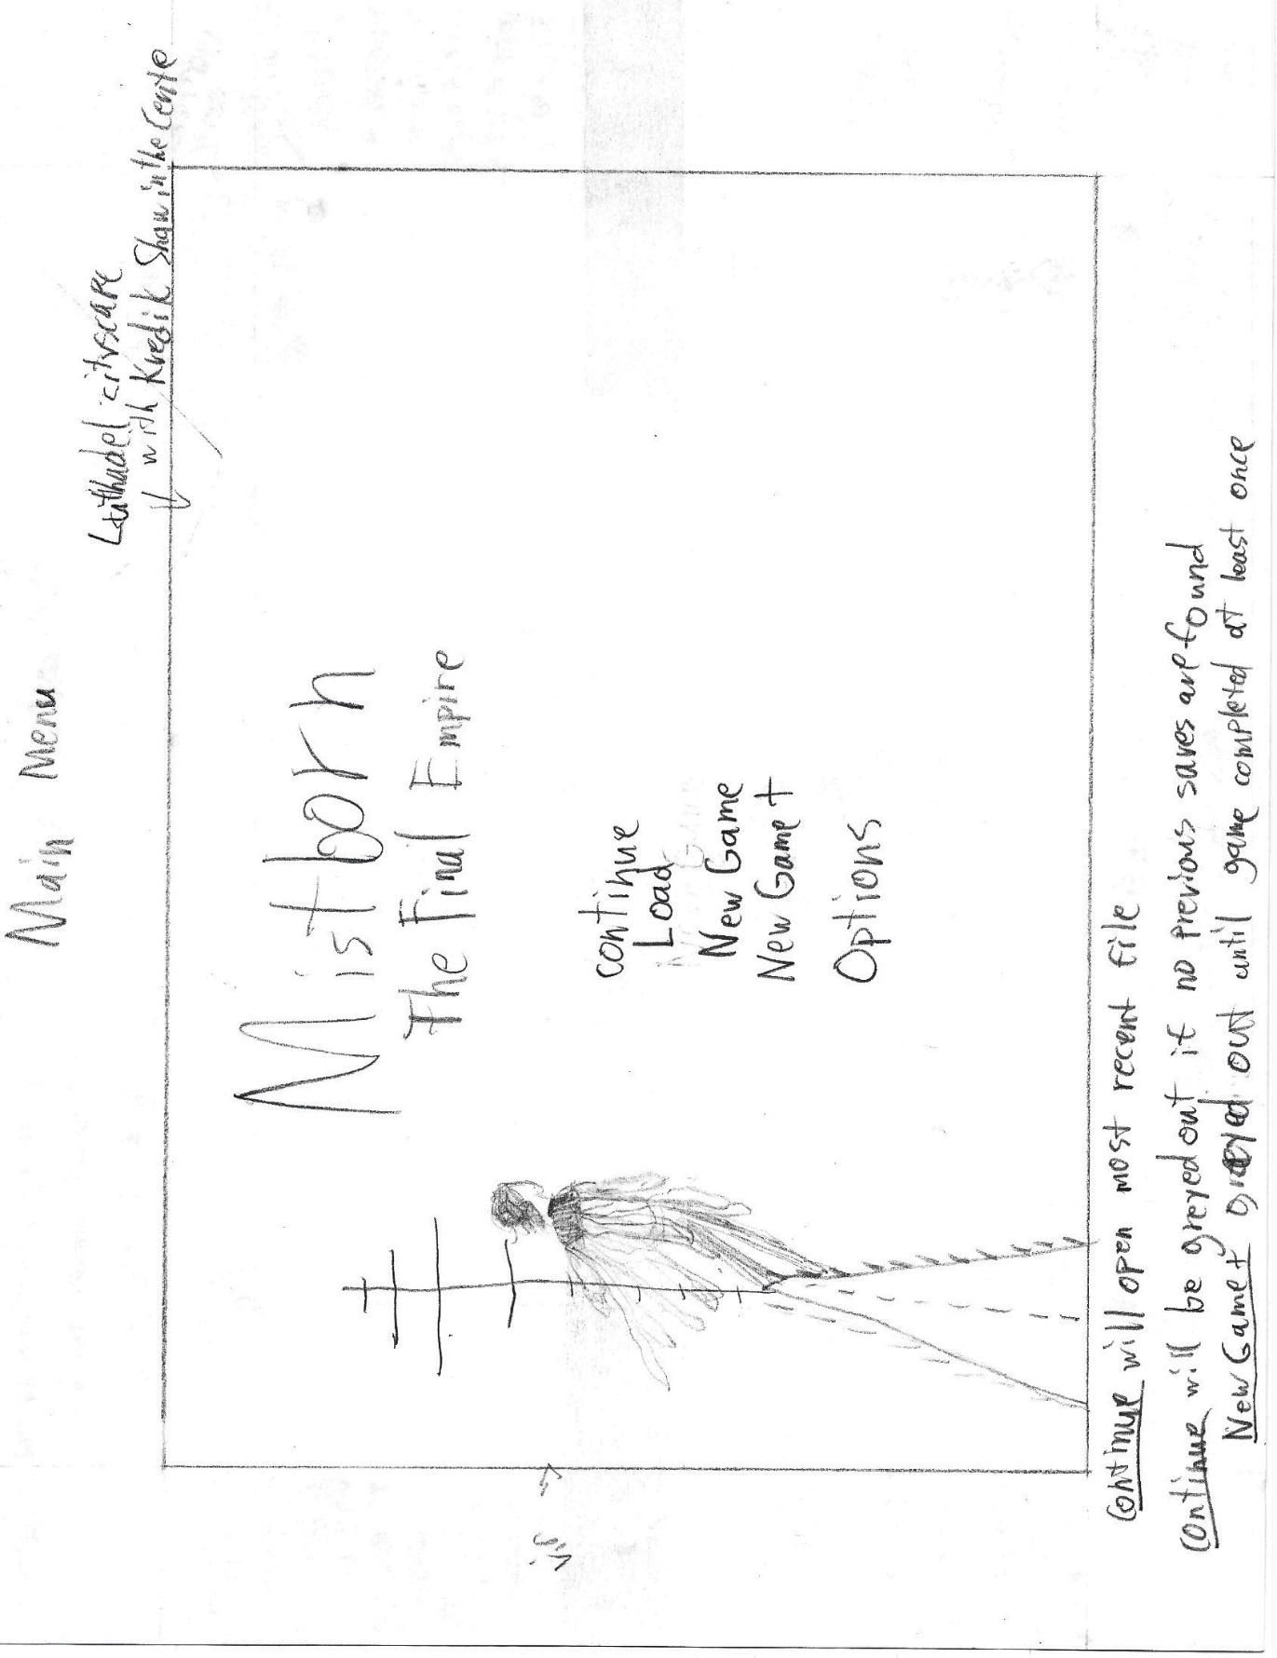

**The Options Menu, Accessible from the Main Menu**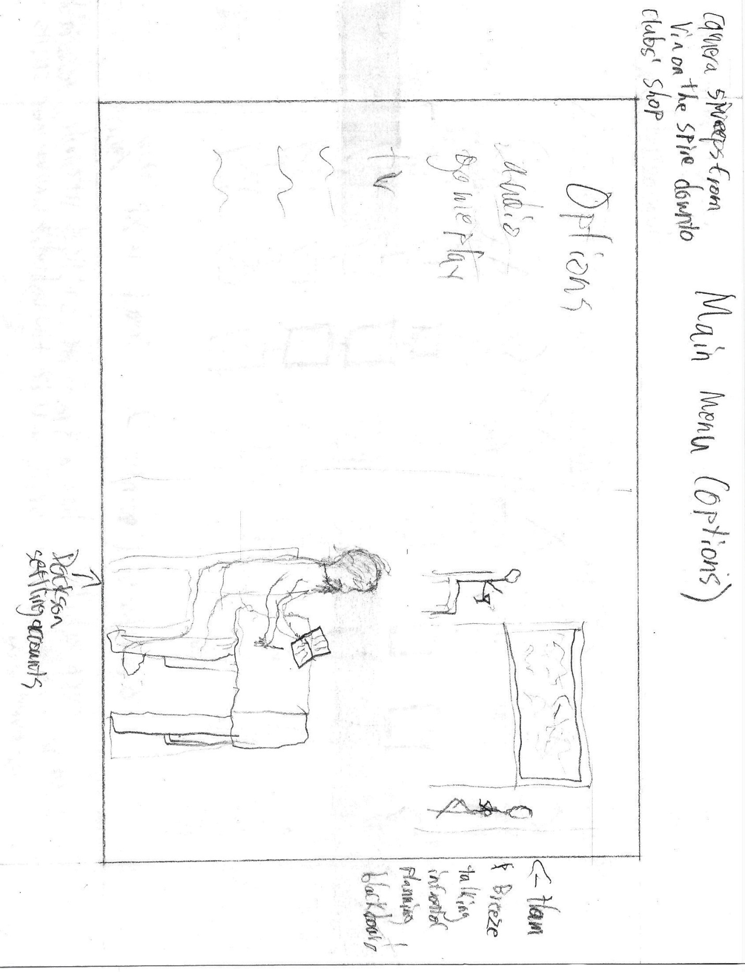

**New Game Menu**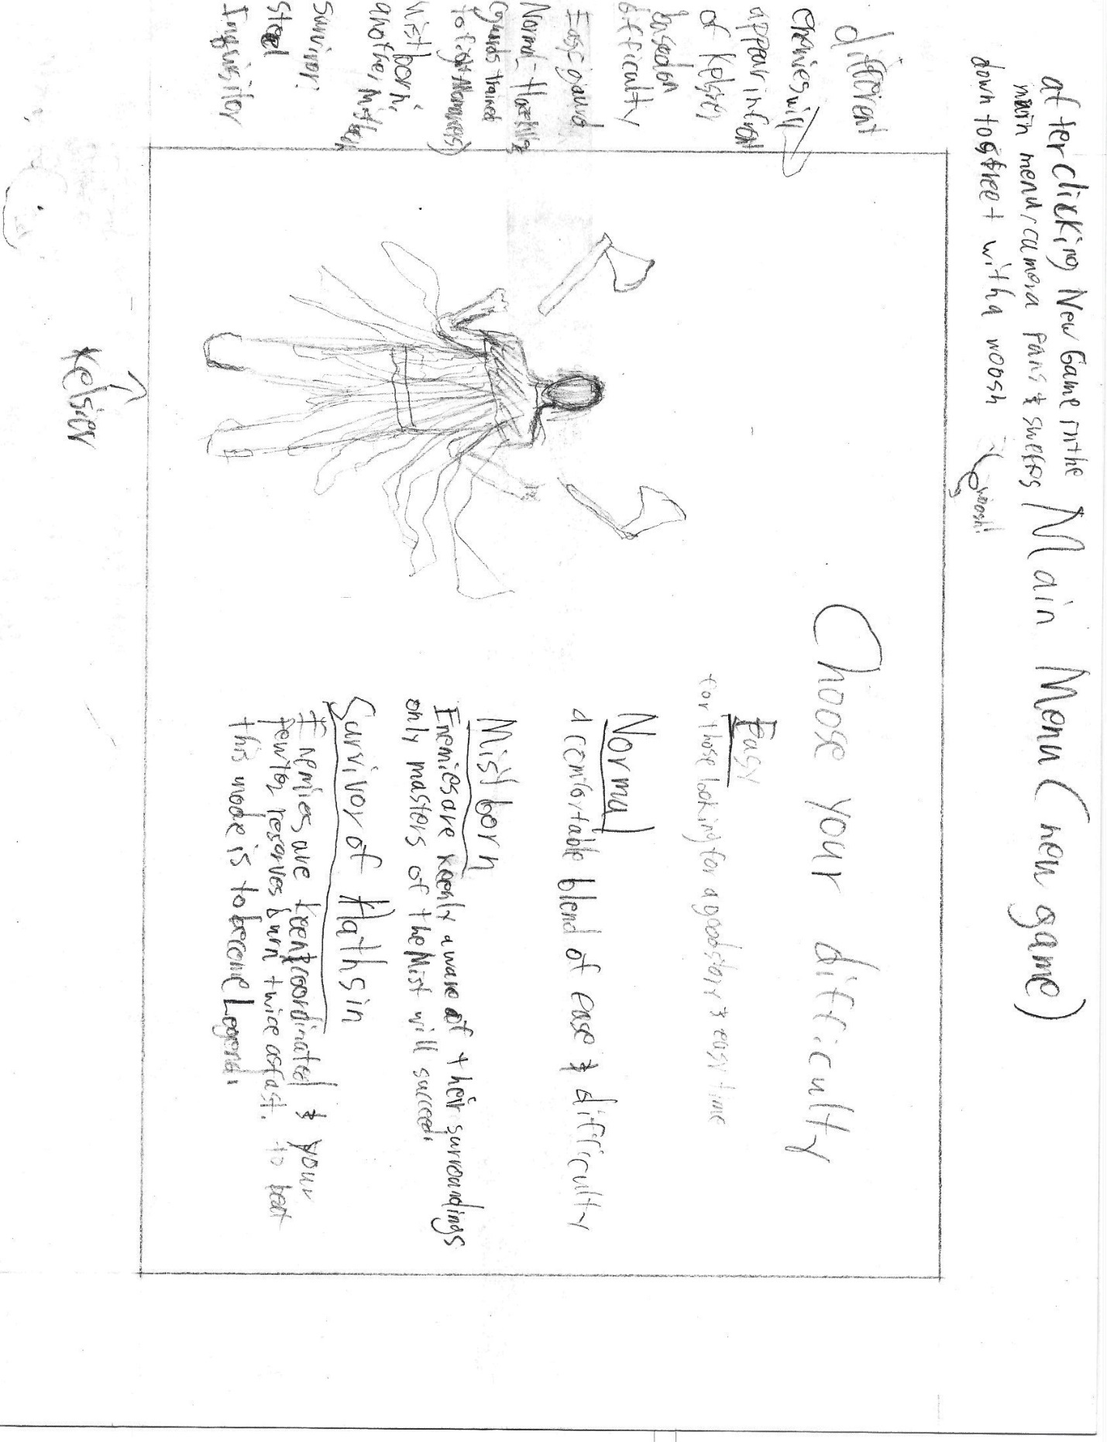

**Normal Gameplay**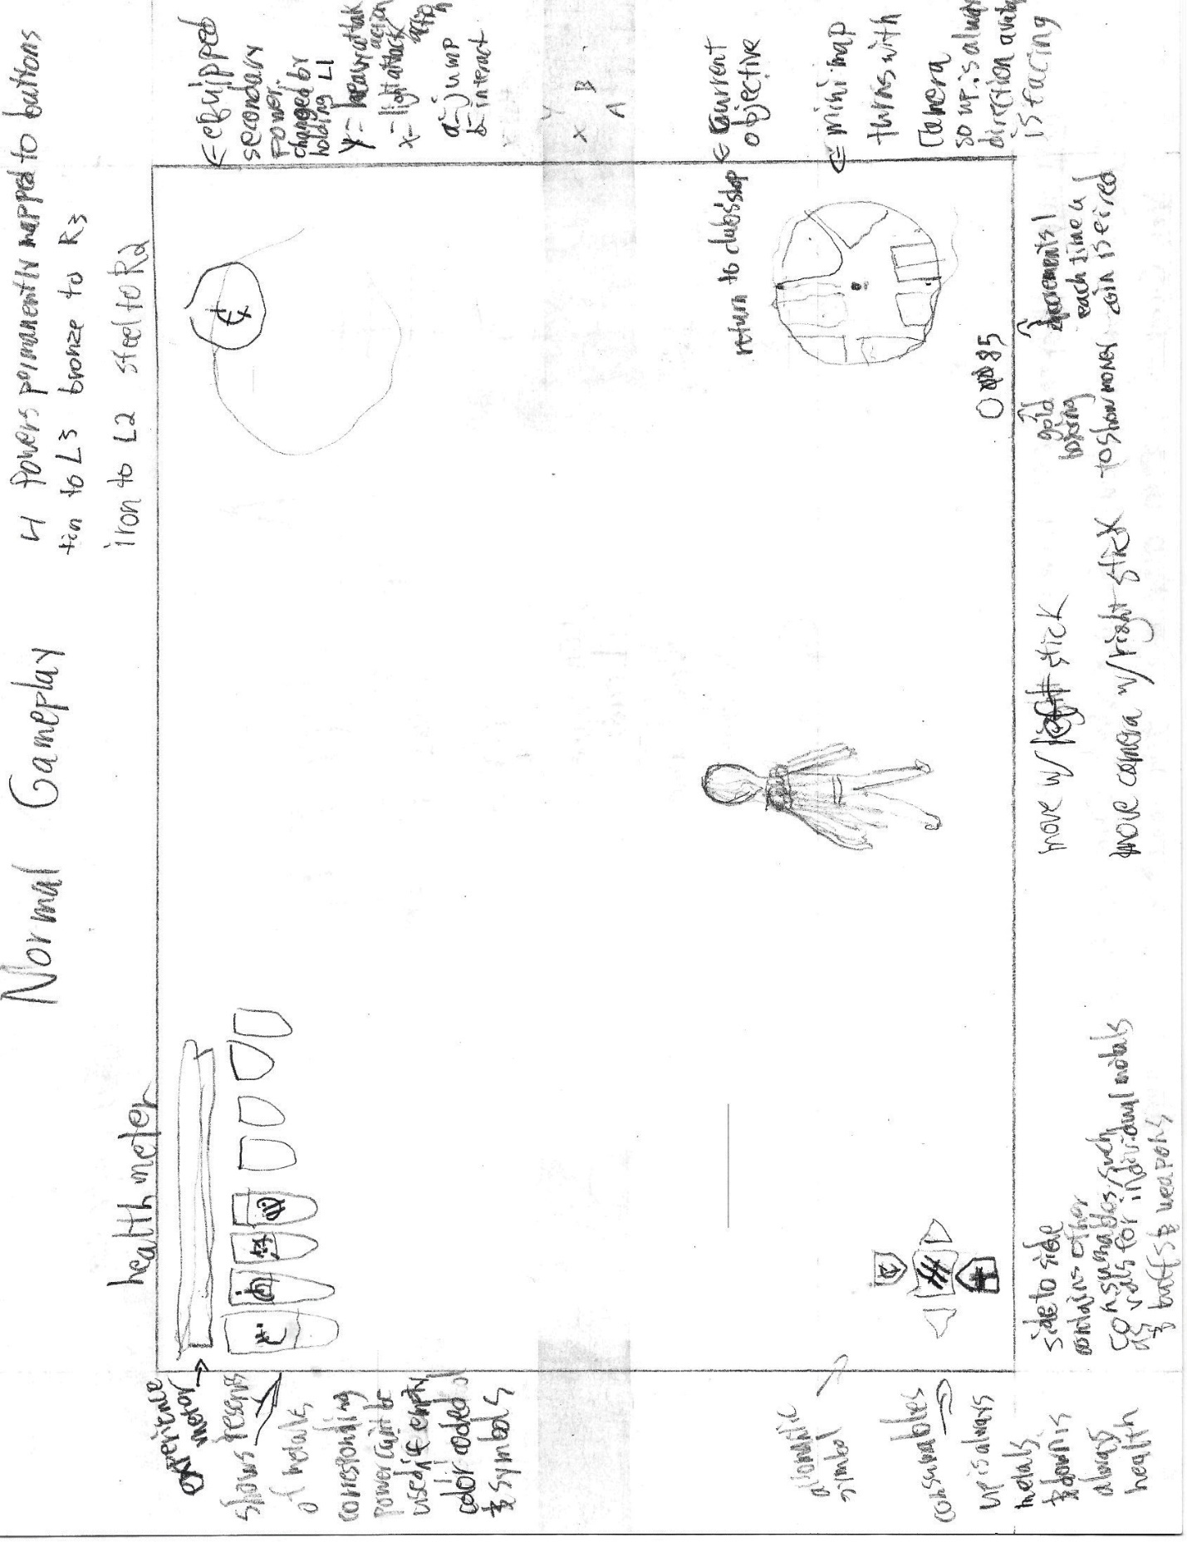

**Inventory Menu**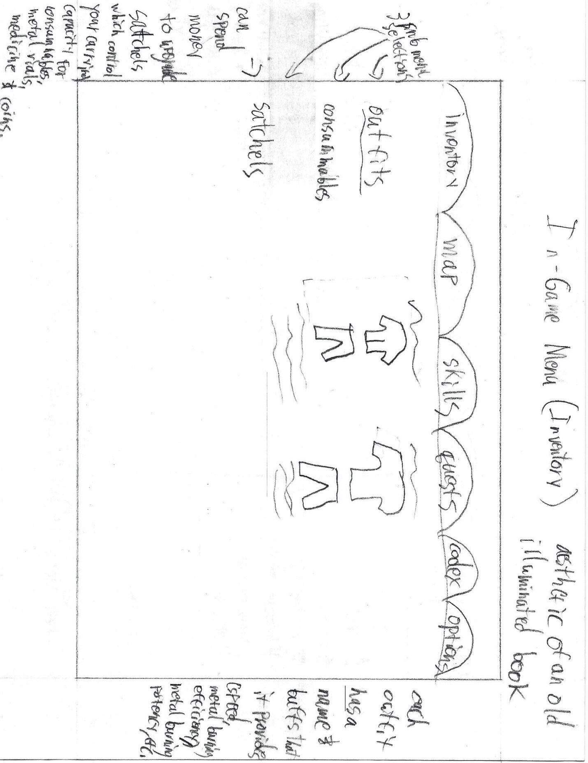

**Map Menu**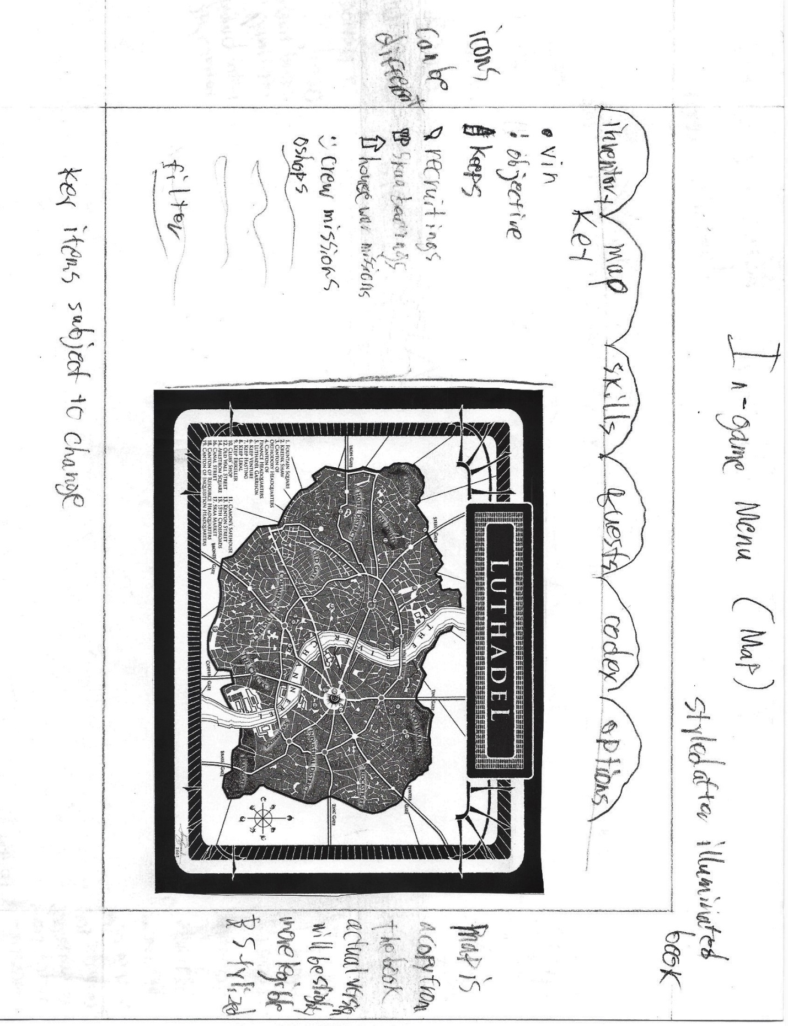

**Skills Menu**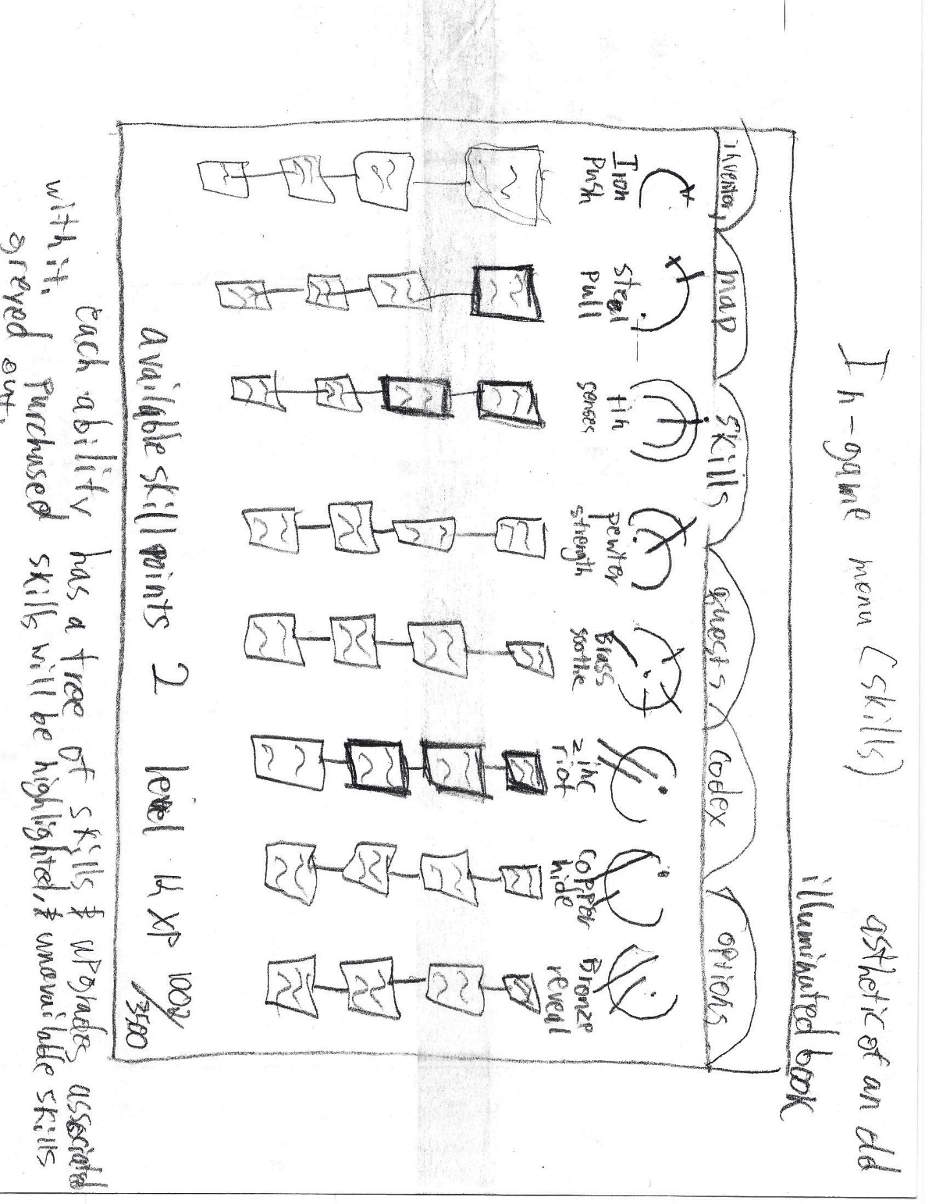

**Quests Menu**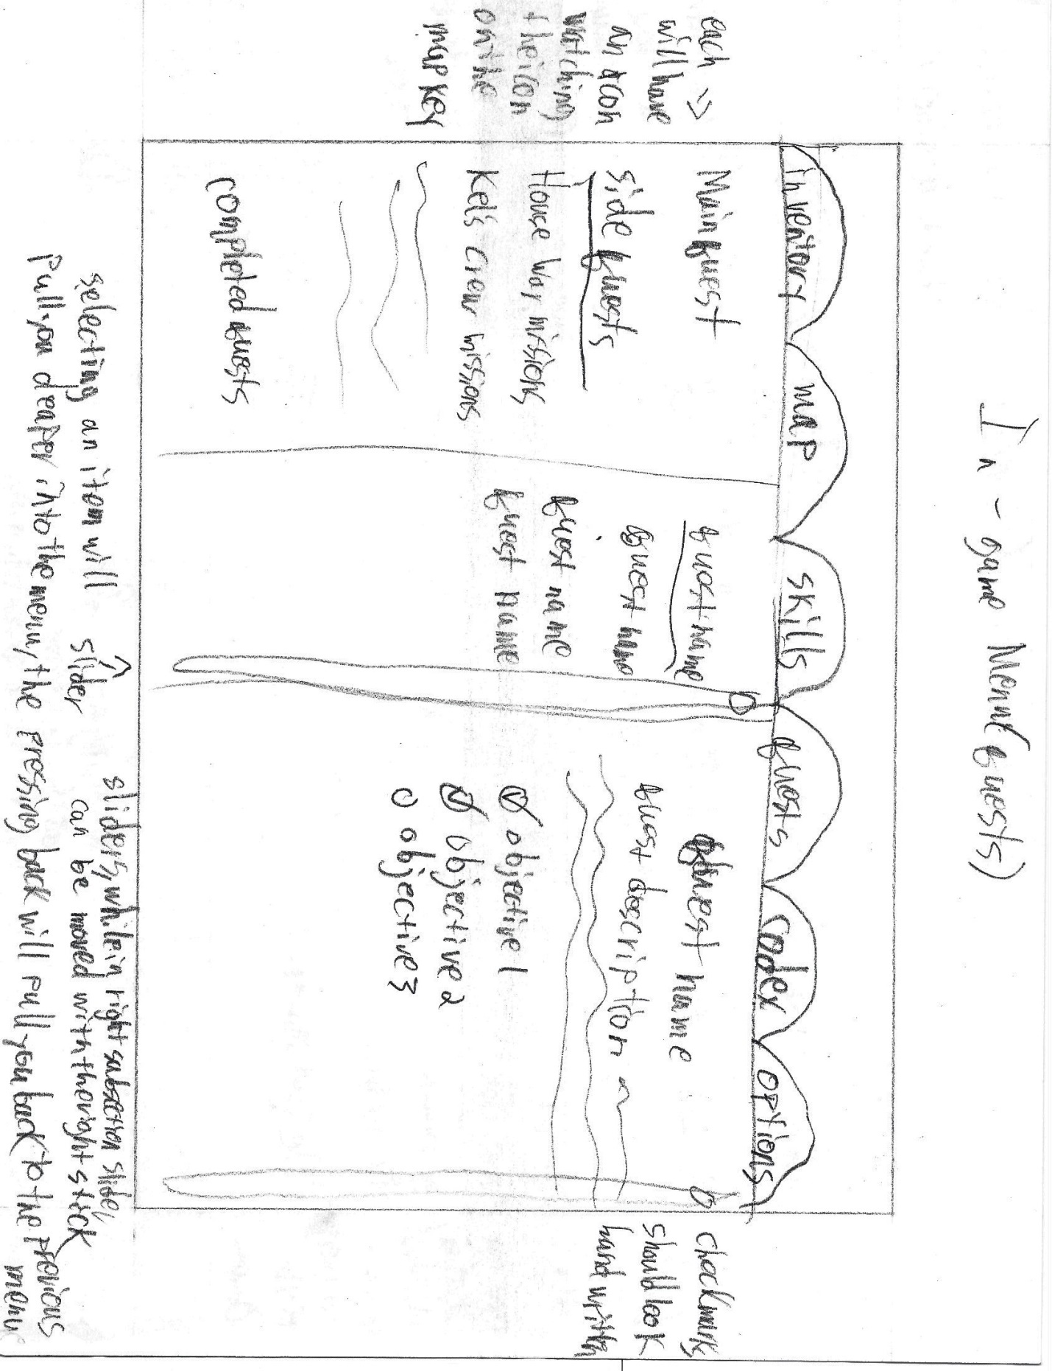

**Codex Menu**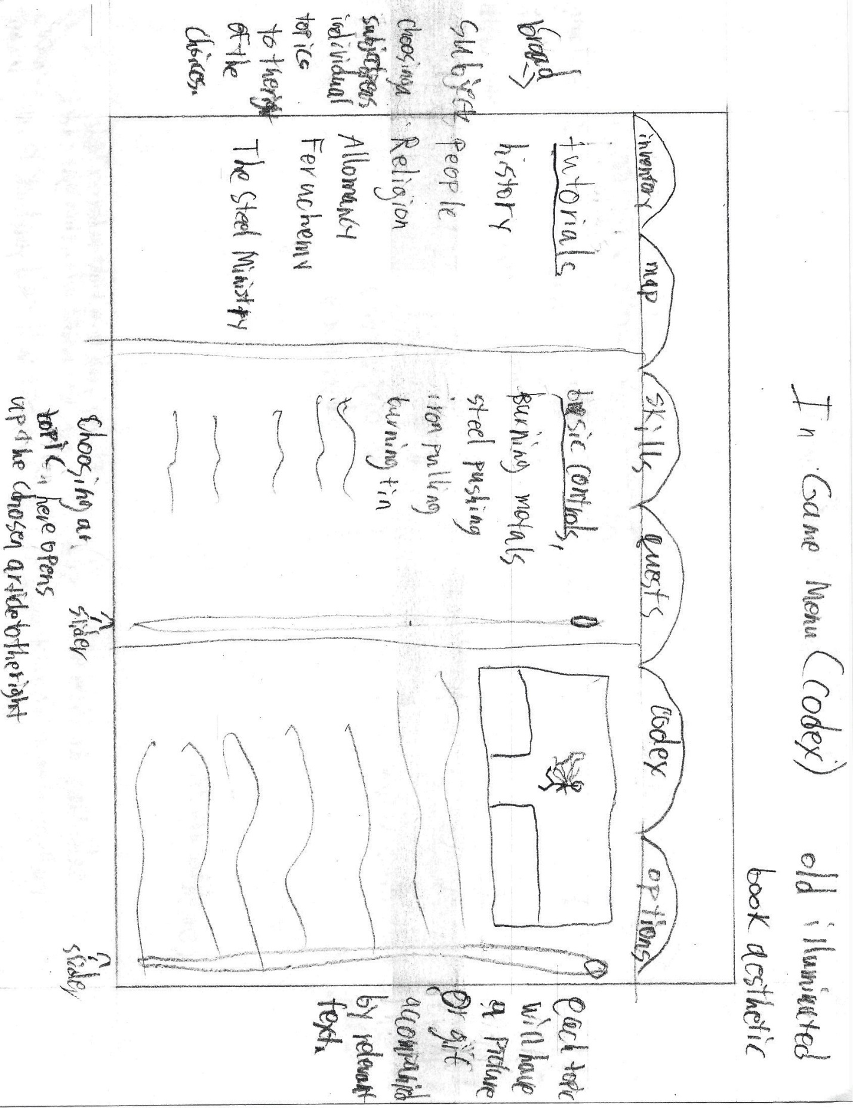

**In-Game Options Menu**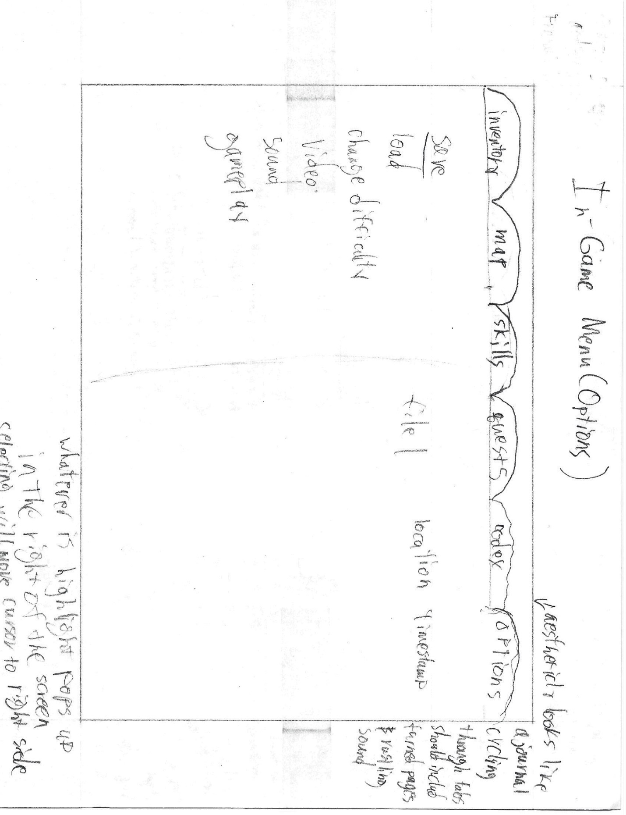

# Story and Level Progression

The very first level is the prologue of the book. On a plantation, the Skaa are mourning the inevitable death of one of their own by the hand of their Noble owner. Kelsier comes out of the mists and hears tell of their plight and goes to the manor. He goes through the manor, sneaking or fighting his way to the Noble to kill him. This serves as an introduction to the gameplay and abilities. Then, through a cut-scene, we see the aftermath of his actions on the Skaa. After a short cutscene for opening credits, we go to Vin as she is taken to the Steel Ministry to try and pull a heist. It’s here that she is discovered by Kelsier and saved from her old crew only a couple days before the Lord Ruler has the crew slaughtered. Meanwhile, Vin is introduced to Kelsier’s crew and the grand plan to build an army, start a house war, loot the Lord Ruler’s palace and topple his regime.

Over the next several hours missions consist of Vin (and the players) learning how to use her abilities, raiding noble caravans, recruiting Skaa to be soldiers, attending balls to perform espionage on the Nobles, and playing as Kelsier in assassinating several high-profile Nobles. During this time Vin grows more trusting and confident. She meets Elend, a Noble who hates the way the Skaa are treated and falls in love with him. Then, just as everything seems to be coming together, word comes that one of the officers of their fledgling army decided to strike to soon and their forces have been decimated. Vin and Kelsier have to run out to the army, kill what ever enemies remain and smuggle what’s left of the army into Luthadel.

Just as this gets taken care of, one of the crews two fronts is discovered, and half of the crew captured. They are set to be executed in the main square for a public execution when Kelsier comes and rescues them. After fighting through countless guards and even killing one of the dreaded Inquisitors, Kelsier is struck down by the Lord Ruler himself. Kelsier dead and his plan in shambles, the crew gives up hope and are about to quit when people begin to speak of Kelsier coming back from the dead and encouraging them to rise up. It turns out that Kelsier hired a shape-shifter to take his form after he had died and ignite the peoples hopes. By becoming a martyr Kelsier started a revolution that toppled the government.

Seeing the people successfully revolting the crew gains hope and Vin learns about an 11th metal that Kelsier was hoping to use to kill the Lord Ruler. She immediately heads out into the chaos to infiltrate Kredik Shaw and kill the Lord Ruler. She is quickly captured by the Canton of Inquisition, the Lord Ruler’s elite policing force, also known as Inquisitors. They prepare her for torture and leave her locked up when she is saved by Sazed, her friend and fellow crew member, who helps her recover her stuff.

Vin goes and finds the Lord Ruler and doesn’t stand a chance. The Lord Ruler is an allomancer several times more powerful than Vin and is also a rare Feruchemist. This combination allows him to basically create infinite youth. Vin burns the 11th metal and only sees a past version the Lord Ruler. Vin puts some pieces together and figures out that the Lord Ruler’s youth must be connected to the bracelets he is constantly wearing, where Feruchemists store their power. Just then, the Lord Ruler gives a massive allomantic push, pushing all metal clear of Vin’s reach and even ripping out her earring. Vin allomantically pulls on the Lord Ruler’s bracelet with everything she has and begins absorbing mist. The more mist she absorbs, the stronger she gets eventually pulling the bracelets free. The Lord Ruler immediately ages and right before Vin kills him, he gives an ominous warning that he was only trying to protect.

Vin finds and puts her earring back in and then goes outside. Elend has managed to prevent the skaa masses from slaughtering every last noble and has brought order to the situation. The fake Kelsier gives everyone in the crew a last message he was instructed to give and the game ends.

# On-Screen Text and Audio Dialog Script

The audio dialogue will be pulled as much as possible from the source material, the book Mistborn. For random NPC chatter, Noble NPCs will talk about the latest political intrigue, gossip about their neighbours, and news from around the Final Empire. The Skaa on the other had will remain mostly quiet speaking in hushed tones. When they do speak out, they will talk to each other about their anger and hardships. The Skaa are rather depressing.

On-screen text will be used to give supplemental instruction with tutorials in the main gameplay screen, as well as current objectives. Because audio dialog will be the primary way of presenting information, the only time that text will be consistently on the screen during normal gameplay is when the subtitles are turned on. In the shell menus, text will be used mostly to present information about the world and its lore.

# Game Script

**Movement:** Lateral movement is unlimited. Character can walk, run and sprint for an infinite duration. Non-allomantically-assisted jumps can gain 3 feet of height and 6 feet in length, 8 if sprinting. Allomantically-assisted jumps can reach 15 feet of height and length but require the use of 1 copper clip. The avatar will automatically grab a ledge and can then move laterally, drop down, or scramble up. Avatar cannot swim. Character can sneak silently but walking and running makes noise and attracts guards.

**Allomantic Powers:** All usage costs are expressed with the understanding that each metal begins with a pool of 100 points before needing to be refilled.

**Iron-push and steel-pull:** Objects must be metal in order to be affected by the push/pull powers. Objects may only be pushed/pulled along a straight line centered around the allomancer’s navel, i.e. once an object is pulled towards/ pushed away from the character, it stays on a straight path between the character’s navel and the point in space that the object is from/being aimed at. When the character is heavier that the object, the object is acted upon. When the object is heavier than the character, the character is acted upon. For example, if a character performs a steel-pull on a building several times their weight, the character will be pulled towards the building rather than vice versa. When the object and the character are of similar weights, both will move at equal speeds towards each other. Pushes can be performed by pushing or placing a coin in a particular spot and then pushing on it. Pushing straight down on a clip or source of metal will propel to a steady height of 15 ft, where they will stay for the duration of the push.

Iron and steel are burned at a rate of 2 points per use. There are also abilities that can be used for a fixed percentage. For example, an ability that shoots metal at all enemies within range would cost 10 points and an ability that creates a storm of metal around you for a limited time will cost 25 points.

**Tin and Pewter:** Tin is used to enhance senses. Burning tin will allow players to scope their vision by up to 10X. It also allows Vin to enter a game mode kind of like eagle vision from assassin’s creed. The world will become slightly discolored as Vin concentrates on sound. She will use her enhanced hearing to create a sonic map of the position of every person and enemy in a range of 50 ft. This will appear as dots on the hud and ghost images giving the player the impression of seeing through walls. Vin will also take notice of wear patterns on the ground that will reveal guard routes within visibility. Tin is burned at 2 points per minute.

Pewter enhances physical attributes. Strength is increased by 3 times. Movement speed is increased by 2 times. Health is increased by 15% and health regenerates at 15 points per minute. These all happen for the duration which the player burns pewter. Pewter burns at a rate of 10 points per minute.

**Brass and Zinc:** Players will come across opportunities where they see two or more NPCs participating in arguments or discussions. Players will be given the option to sooth(brass) or riot(zinc) the NPCs emotions. Depending on the situation, results of soothing or rioting will be different. Each instance of use will cost 5 points.

**Copper and Bronze:** Burning copper prevents Vin’s activities from being noticed by enemies. It is constantly burning in the background at a rate of 3 points per minute. If copper runs out, members of the Steel Ministry will begin to spawn and attack Vin. Enemies will spawn at a constant rate of 3 enemies per minute until the copper reserves are replenished, at which point enemies will cease to spawn.

Burning bronze allows Vin to distinguish an enemy’s abilities. When burned, every enemy within a 50 ft radius that has allomantic powers and is not protected by a copper cloud will be tagged with a color coordinating with their ability and their ability will be displayed when Vin focuses on a particular enemy. Bronze costs 3 points for each use.

**Atium:** When burning Atium, the player is effectively invincible. The players avatar cannot be hit, attacks will never miss, and the likelihood of critical hits is doubled. If the player decides to do nothing while an enemy is attacking, the avatar will automatically reposition to avoid getting hit. If the player is fighting another mistborn also burning Atium, combat returns to normal and all buffs are cancelled out. If the player fights a character burning Atium without burning Atium themselves, all buffs are applied to the enemy. Atium burns at a rate of 1 bead per minute. Characters are only allowed to have 3 beads in their inventory at a time, though more may be stored at the crew’s headquarters.

**Combat:** Combat is split up into 3 main portions: melee, ranged and stealth

**Melee:** During melee combat, players will have 3 main inputs: heavy attack, light attack and dodge. Dodging will move the player in whatever direction the player directs at the time of the button press, and the player cannot take any damage from the moment the button is pressed to 1 second after the dodge animation ends. Light attacks move quickly and come in combos of 4 button presses, with the final attack in the combo dealing an extra 10% damage. Heavy attacks move more slowly, have 3 button combos and the final combo adds an extra 20% damage. Various combos can be made, but the final hit in the combo will add extra damage corresponding to whether the final attack was heavy or light.

Enemies may drop melee weapons during a fight. Vin can pick up these weapons and use them. Each will have differing attributes (range, strength, speed, etc.), but the button combos remain the same throughout all the weapons. When combat is over, Vin will drop the weapon. these weapons cannot be added to inventory.

**Range:** Ranged combat consist of iron-pushing on coins to propel them at deadly speed. Each shot fired uses 1 copper clip, the smallest denomination of money. Headshots are instant kills for unarmored enemies and triple damage for armored enemies. Shots can accurately hit a target up to 150 ft. away. Beyond that, no damage will be dealt

**Stealth:** When crouching, Vin can move up to ½ of her normal speed. Dropping from heights produces no sound. Takedowns can be performed from above, from a ledge, and from around a corner. Takedowns are lethal to all but bosses, heavily armored foes, and enemies burning pewter, in which cases triple damage is applied. Enemies must be within three feet of the avatar, or the point directly beneath the avatar, in order to perform a takedown. Vin will always have the option to perform lethal or non-lethal takedowns. Kelsier will always perform lethal takedowns until his last playable mission. Enemies have a cone of vision about 80 degrees wide and a seeing distance, while unobstructed, of 25 feet.

**Leveling Up:** Throughout the game, players will earn experience points that are put towards leveling up. Once enough points are earned, the player levels up and a new goal is set that requires more XP than the previous goal. Upon leveling up, the player’s HP is increased by 50 points and the player earns a skill point to be used for skill upgrades.

**Upgrades:** There are 2 types of upgrades, skill upgrades and material upgrades. Skill upgrades are tied to the player’s allomantic abilities. Each ability has a small skill tree that has passive skills, such as a more efficient burn rate, and active skills, such as shoot a coin at each enemy within range simultaneously. The player buys these skills using skill points earned by leveling up and completing certain story missions.

Material upgrades are purchased in stores found across Luthadel. These upgrades include wallet size, metal vial size (giving the player a larger metal reserve to burn before needing to replenish), clothes with different buffs and armor, and better obsidian daggers. Most upgrades are purchased with regular money, the same money used as ammunition. High-end, end-game materials, however, are purchased using Atium beads. Players must balance their usage of these resources in battle with their desire to purchase jupgrades.